ATM FLOW  
  
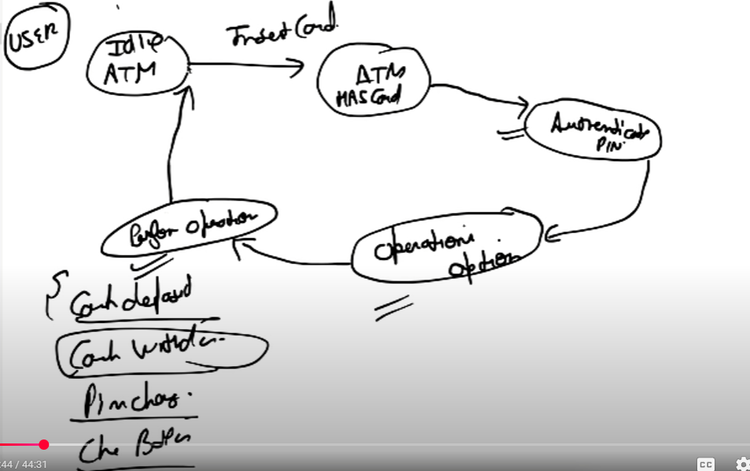  
  
  
  
List of operations  
  
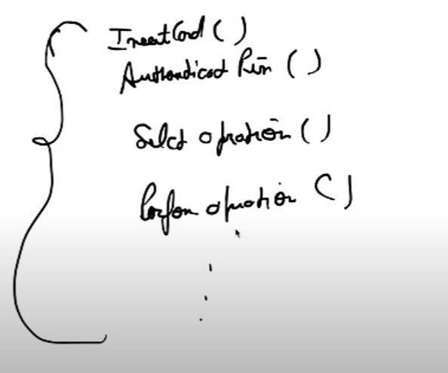  
  
Also each operation is divided into diff states  
  
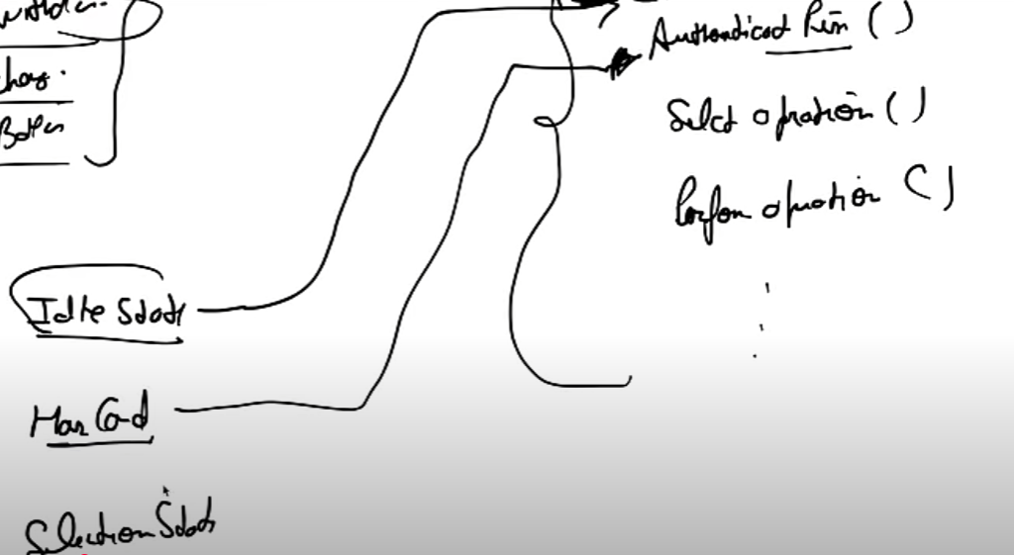  
  
  
  
  
Chain of responsibility comes into picture for the withdrawal process

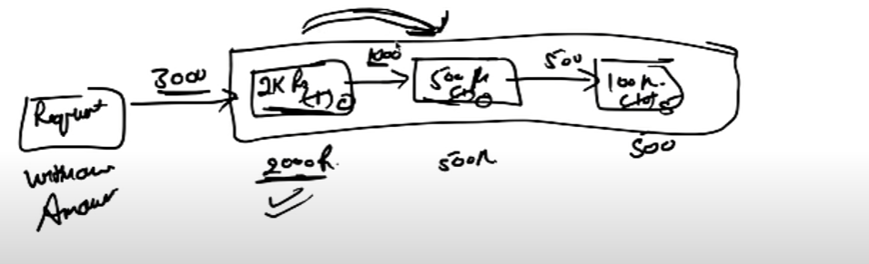  
  
  
  
UML

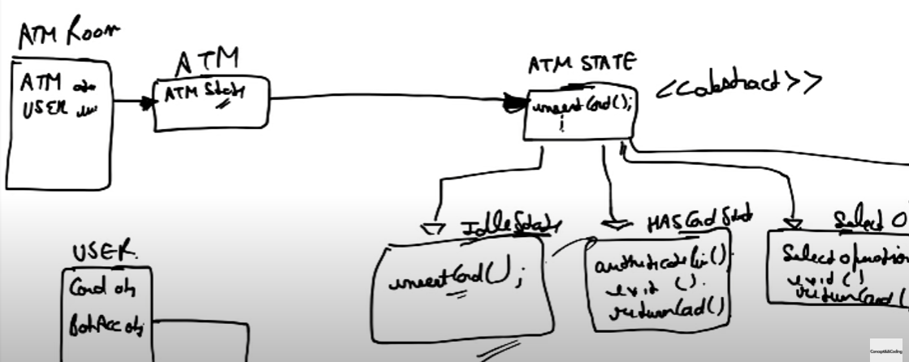

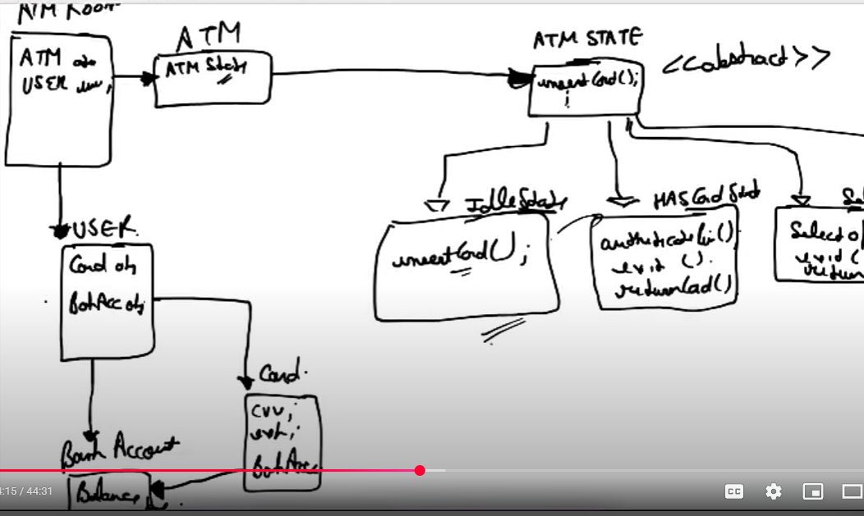  
  
  
  
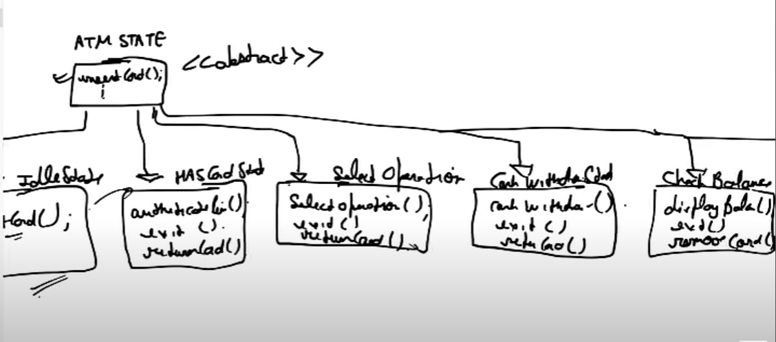

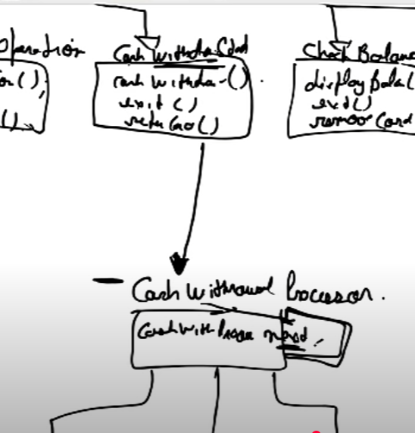  
  
  
  
  
  
  
  
  
  
Chain of resp

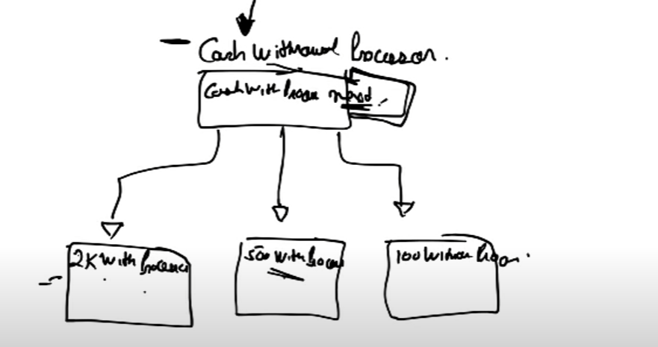  
  
  
  
Full diag  
  
